1. Clone the git repo you want to change.

- copy git repo url

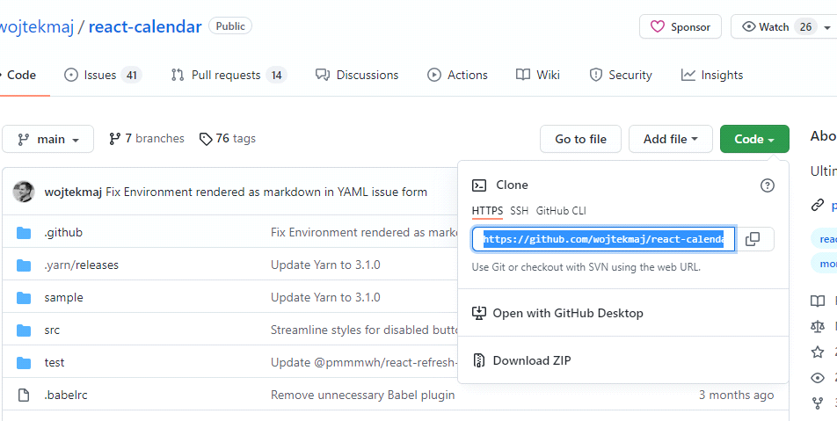

- clone repo

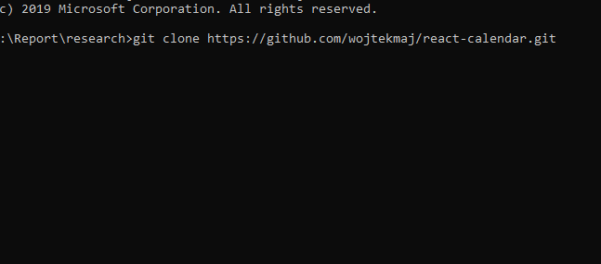

1. Open Bash in the cloned directory.

3. Run the below command to change the email and author.

At that time, please confirm to replace CORRECT_NAME and CORRECT_EMAIL with yours

git filter-branch -f --env-filter '

CORRECT_NAME="David"

CORRECT_EMAIL="senseofpriderenovation@gmail.com"

export GIT_COMMITTER_NAME="$CORRECT_NAME"

export GIT_COMMITTER_EMAIL="$CORRECT_EMAIL"

export GIT_AUTHOR_NAME="$CORRECT_NAME"

export GIT_AUTHOR_EMAIL="$CORRECT_EMAIL"

' --tag-name-filter cat -- --branches --tags

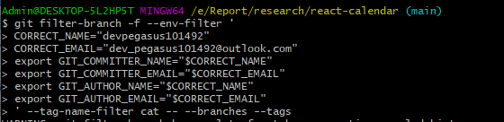

4. Create new private repo on your git account.

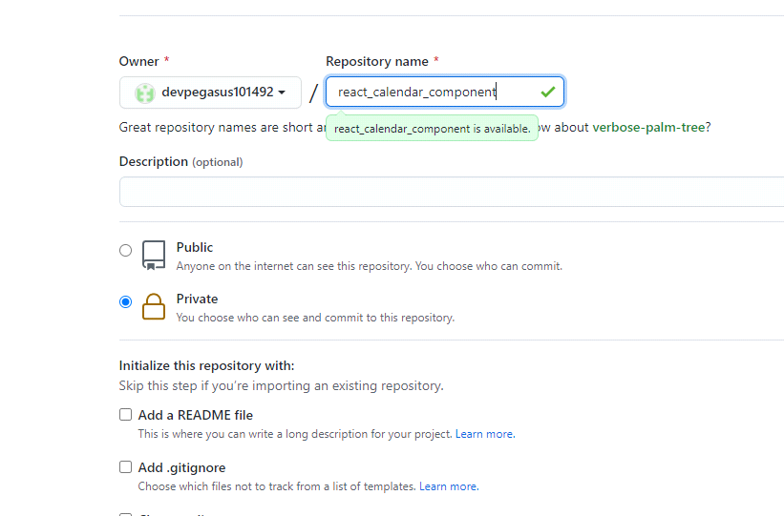

1. Push the changed repo to your new repo.

- change origin url



- check if relevant information is replaced

git remote set-url origin

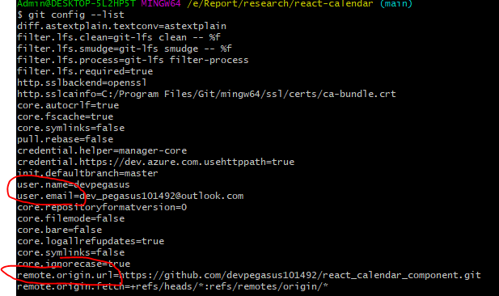

- push to remote branch. In this case the branch name is “main”



- You have to add tokens to windows credential manager to connect to remote branch

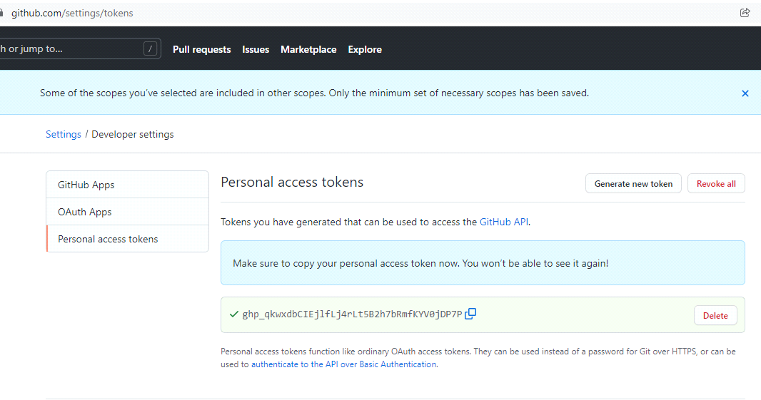

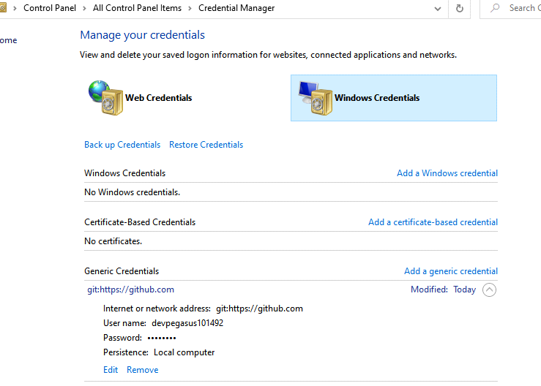

1. Confirm your git profile.

- You need to set contribution-to-private repo displayed

